Web access to Windows Virtual Desktop

Open this link:
https://rdweb.wvd.microsoft.com/webclient
You will be presented with the available Windows Virtual Desktop to you.
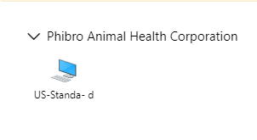
When launch the WVD, you will be presented with “Access local resource”
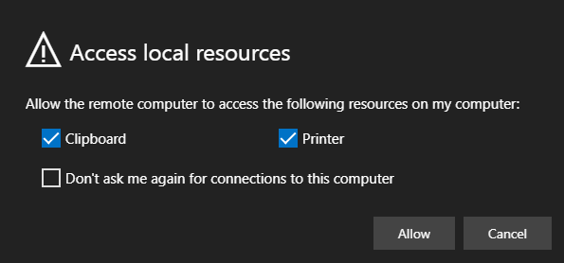

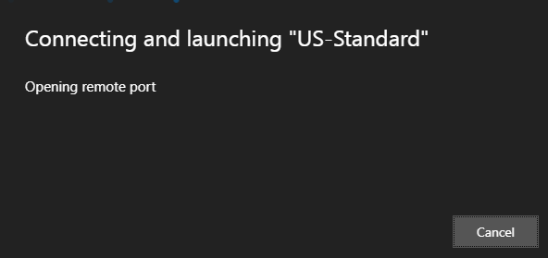
Type your credentials
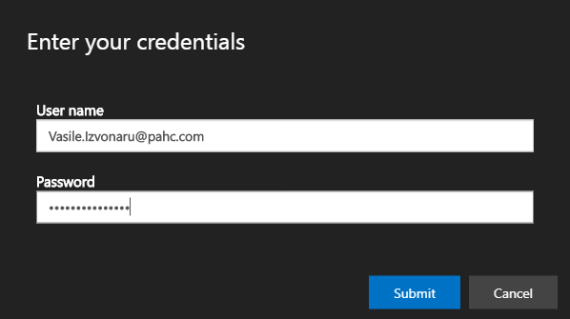
And you will be presented with the WVD.
Thank you.

